Tool Guide – BED Tool

Introduction
BED (Bruteforce Exploit Detector) is a sophisticated tool designed to check network services for a range of security vulnerabilities, including buffer overflows and format string weaknesses. It sends specialised vulnerability detection requests and captures service responses to identify potentially exploitable conditions.
BED is useful during security assessments for both service enumeration and targeted checks, including authentication testing where applicable, to help you find services that may require further investigation.
Safety Disclaimer: Only run BED on systems that are owned or where explicit permission to test has been granted. Scanning unauthorised systems can be illegal and unethical.

Setup and Launch
Step 1: Open Deakin Detonator Toolkit
- Launch Terminal in your Kali Linux or other supported Linux environment.
- Navigate to the directory where the Deakin Detonator Toolkit is located, for example:
cd ~/Deakin-Detonator-Toolkit

- Start the toolkit using the command:
yarn run tauri dev
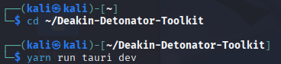
- This will launch the main interface of the toolkit.

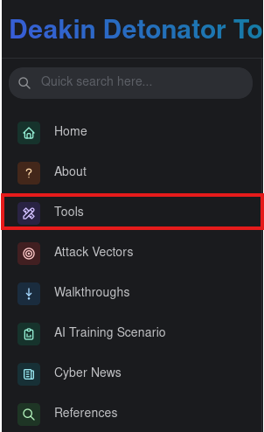
Step 2: Locate the Tool
- In the toolkit, click ‘Tools’ from the left-hand side menu or use the search bar.

- Look for ‘BED’ under the Information and Gathering Analysis category.
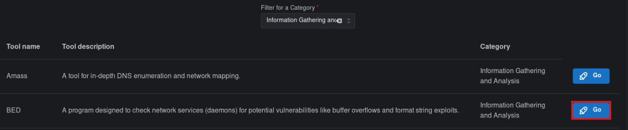
- Click the blue ‘Go’ button next to the tool name to open it.

Configuration
- The tool interface contains three tabs: User Guide, Configuration, and Tutorial.
- Go to the Configuration tab in the tool interface.
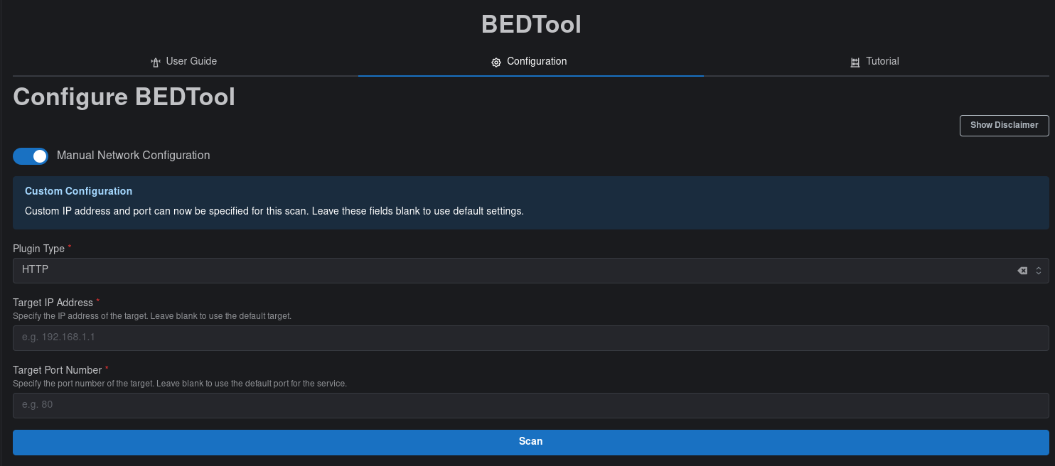
- Turn on Manual Network Configuration to enter a specific IP address and port. Otherwise, the tool will test the local machine.
Example: HTTP selected, and Manual Network Configuration turned on. Enter the IP and port to scan a specific host.
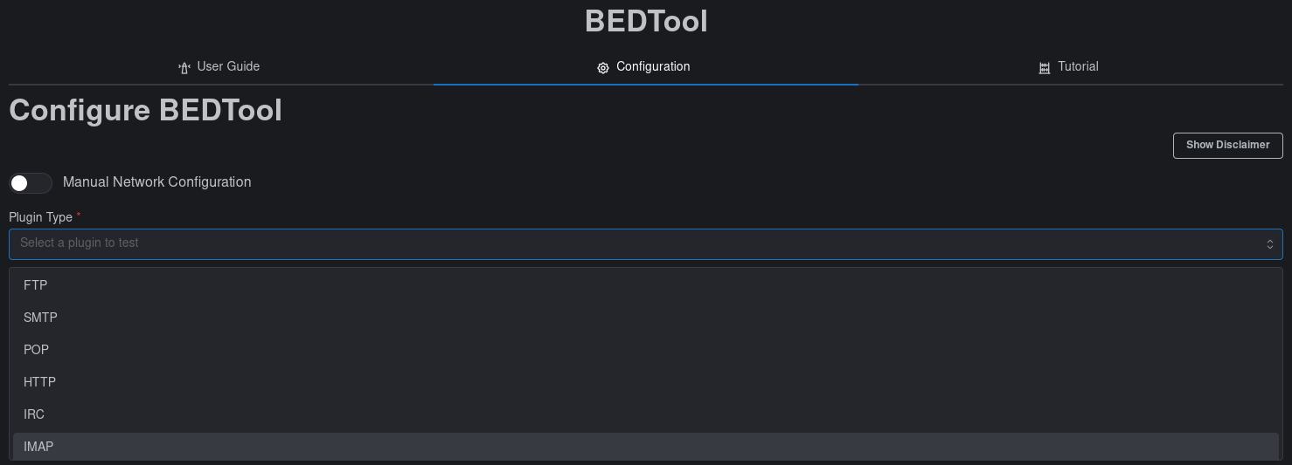
- Select the Plugin Type from the dropdown menu.
Example: Choosing a plugin from the dropdown menu to decide which service to test.

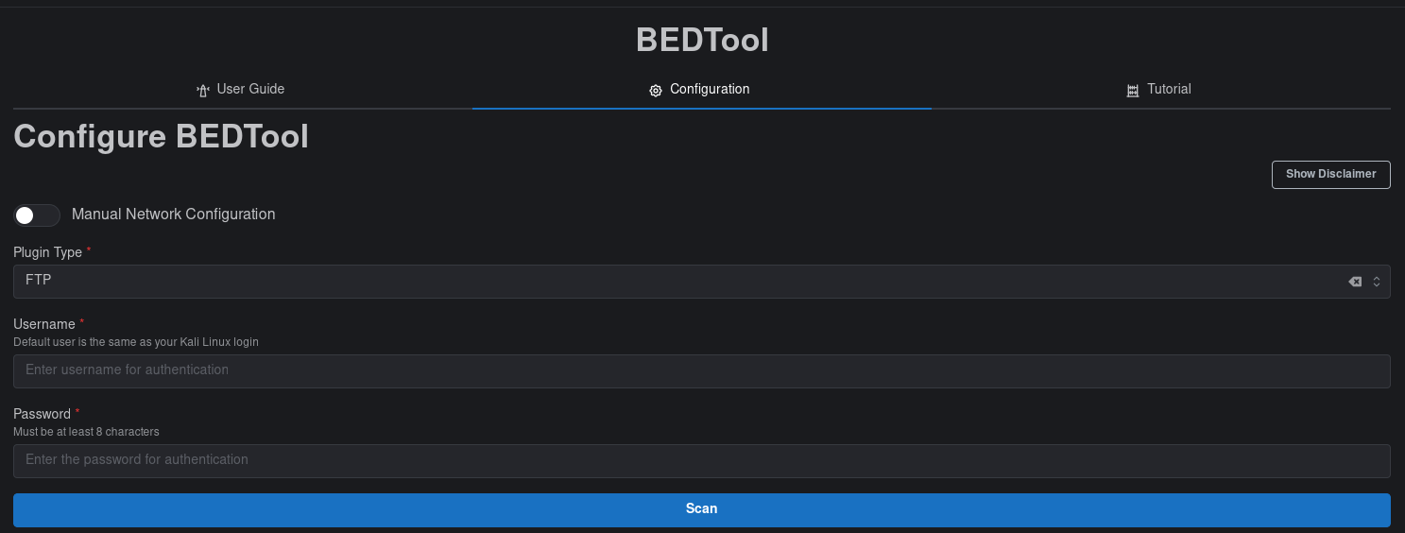
- Fill in any extra fields that appear based on the plugin choice. Different plugins require different credentials.
Example: FTP selected, showing the username and password fields needed to test authentication.
- Click the Scan button to start the scan.
- While scanning, a Cancel Process button appears to stop the scan early.
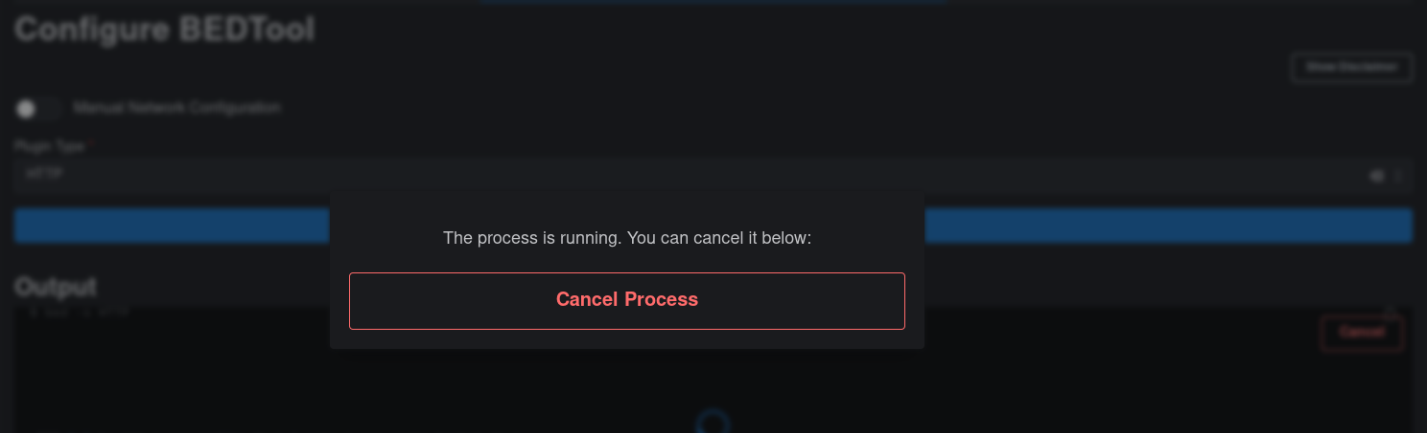

- After the scan completes, review the console output for results.

Output
- The console displays all scan results at the bottom of the interface. The output typically includes:
  - Tool Information: BED version and author details.
  - Test Categories: The types of vulnerability tests performed (e.g. Normal tests, Buffer overflow testing).
  - Individual Test Results: Each line corresponds to a single test, showing details about the exploit condition tested.
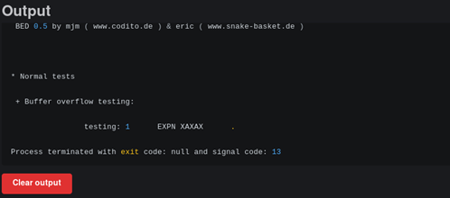
  - Process Status: Indicates whether the scan completed successfully, was cancelled, or encountered an error.

Example Output: The console shows the tool version, test categories, individual results, and the process status.

Saving, Clearing, and Resetting Output
- After scanning (or after cancelling):
  - Click Save Output to File, type a filename (e.g., output.txt), and save.
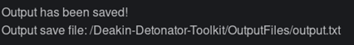

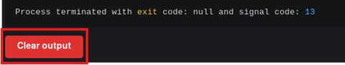
- Click Clear Output to remove all results from the current session.

Troubleshooting
Common Issues & Fixes:
- If the Scan button does not start the scan, check that the required fields (plugin, credentials, IP/port if using manual configuration) are filled correctly.
- If the Cancel Process button does not appear, the scan may have already completed, or the process failed to start. Try restarting the tool.
- If a ‘Connection refused’ or similar error appears in the console, ensure the target IP and port are correct and that the service being tested is running and reachable.
- 'Permission denied' errors: Some services may require specific user privileges, or the target system may have access controls in place.

